Task on ASG
- Create one VPC in N. Virginia region.
- Selected US East (N. Virginia) region in Amazon Web Services Console.
- Created a new VPC named My VPC with CIDR block 10.0.0.0/16 successfully.
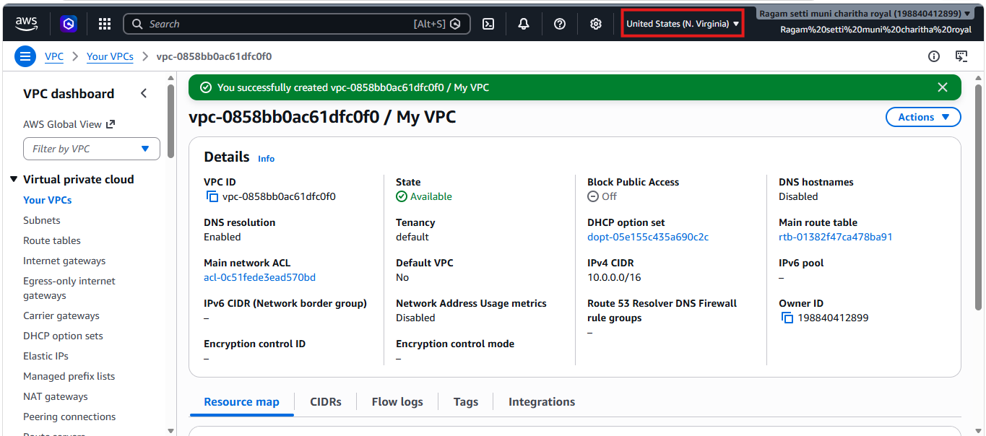
- Create two subnets: one public subnet and one private subnet.
- Selected the created VPC and opened the Subnets section in Amazon Web Services Console.
- Created two subnets successfully: Public Subnet with CIDR block 10.0.1.0/24 and Private Subnet with CIDR block 10.0.2.0/24 in the VPC.
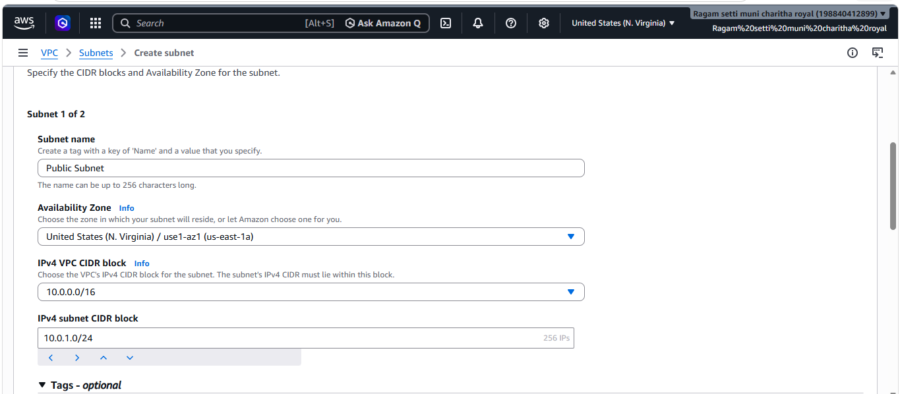
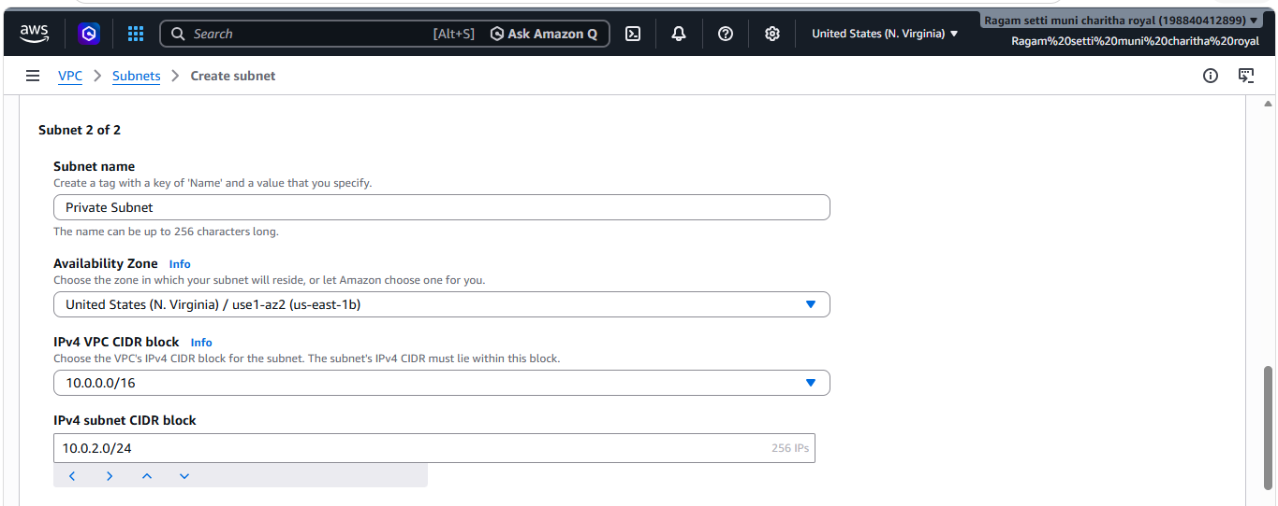
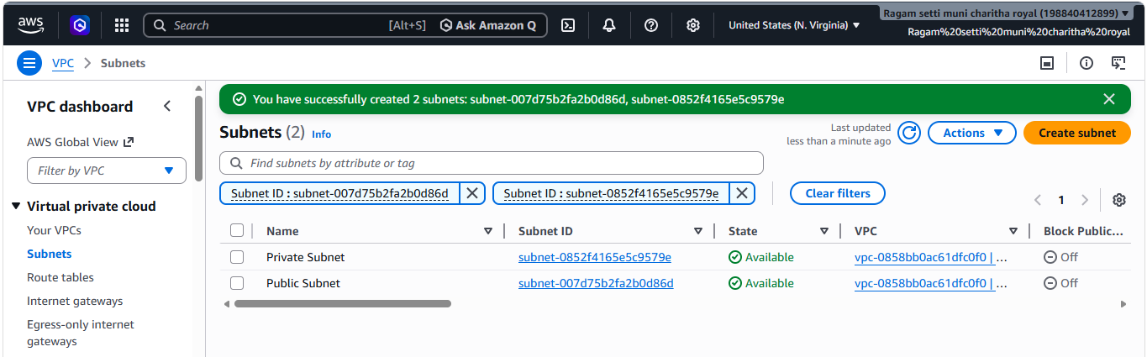
- Attach an IGW to the VPC.
- Created an Internet Gateway and attached it to the VPC successfully in Amazon Web Services Console.
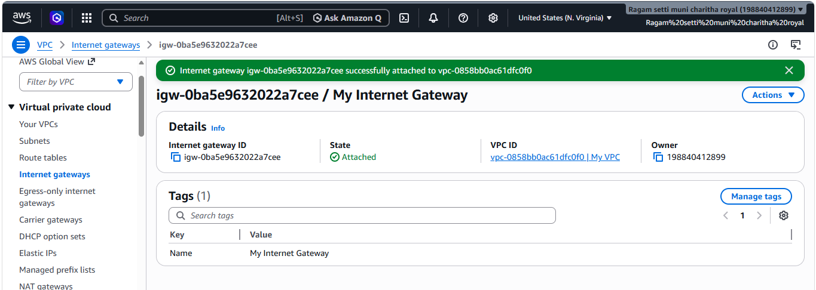
- Create one public route table (RT) and one private route table.
- Created two route tables successfully: Public Route Table and Private Route Table for the VPC in Amazon Web Services Console.
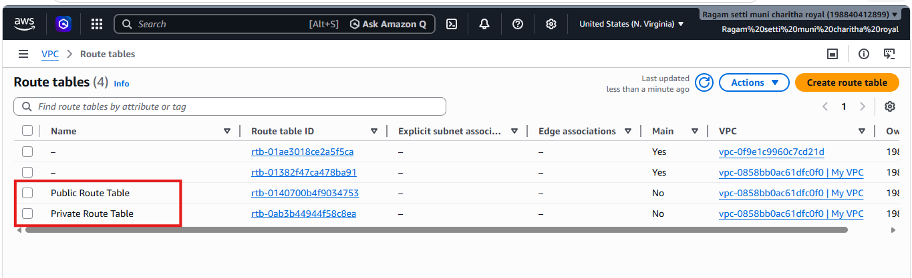
- Deploy a NAT gateway in the public subnet and attach the NAT gateway to the private subnet.
- Opened NAT Gateways in the VPC dashboard, created a NAT Gateway in the Public Subnet, and allocated an Elastic IP.
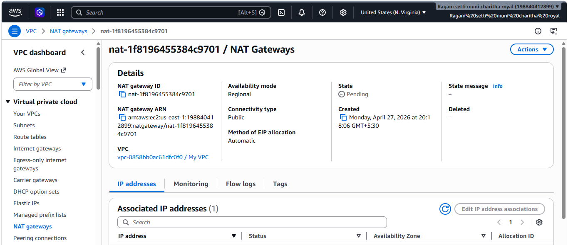
- Updated the Private Route Table by adding route 0.0.0.0/0 → NAT Gateway and associated it with the Private Subnet successfully.
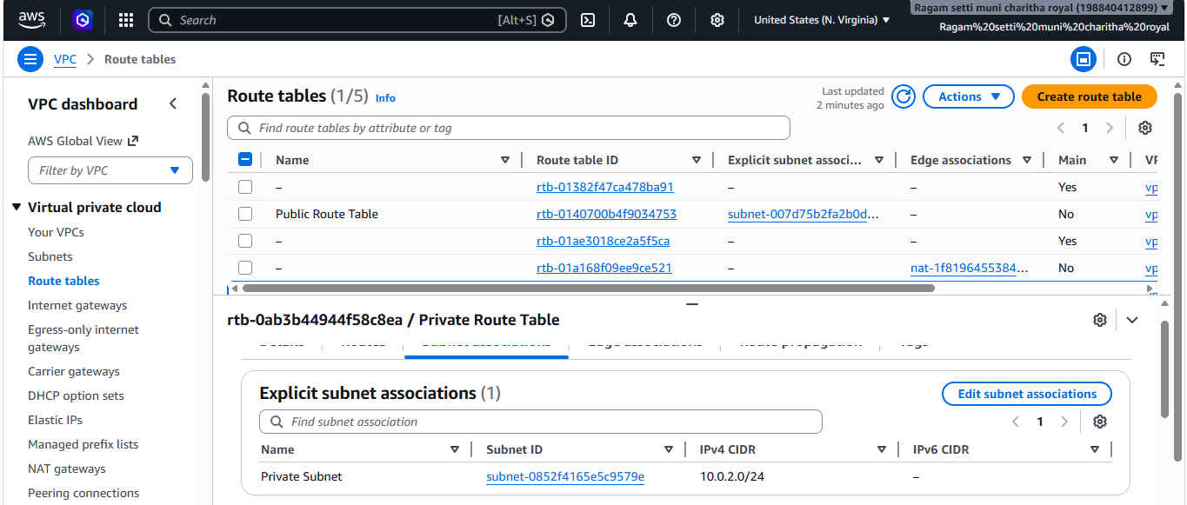
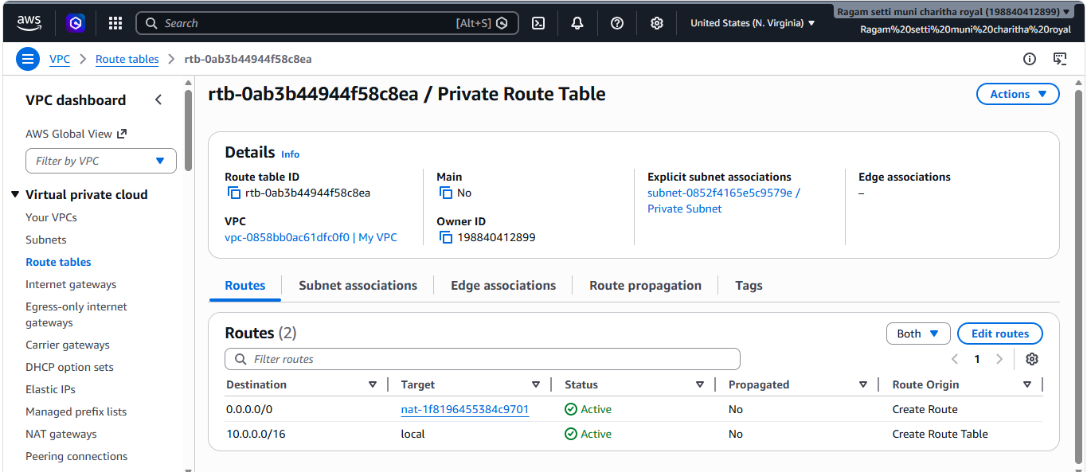

- Create two instances, one in the public subnet and one in the private subnet.
- Created one instance in the Public Subnet with public IP enabled.
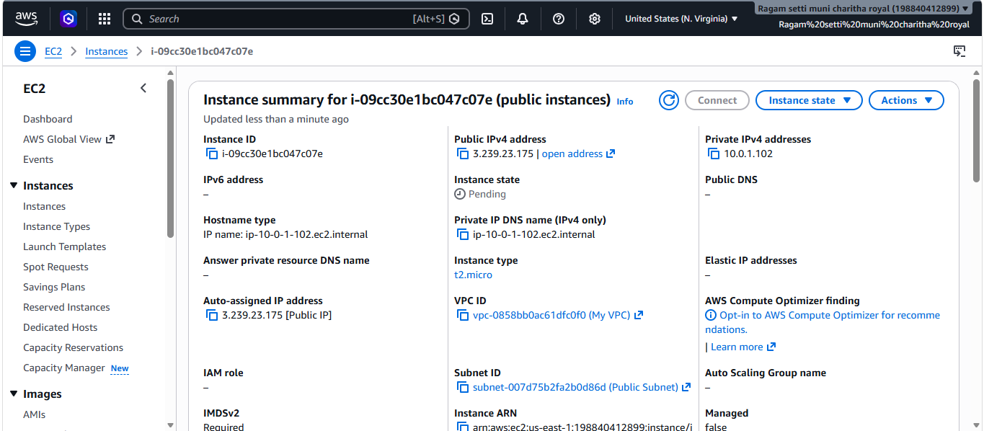
- Created another instance in the Private Subnet without public IP.
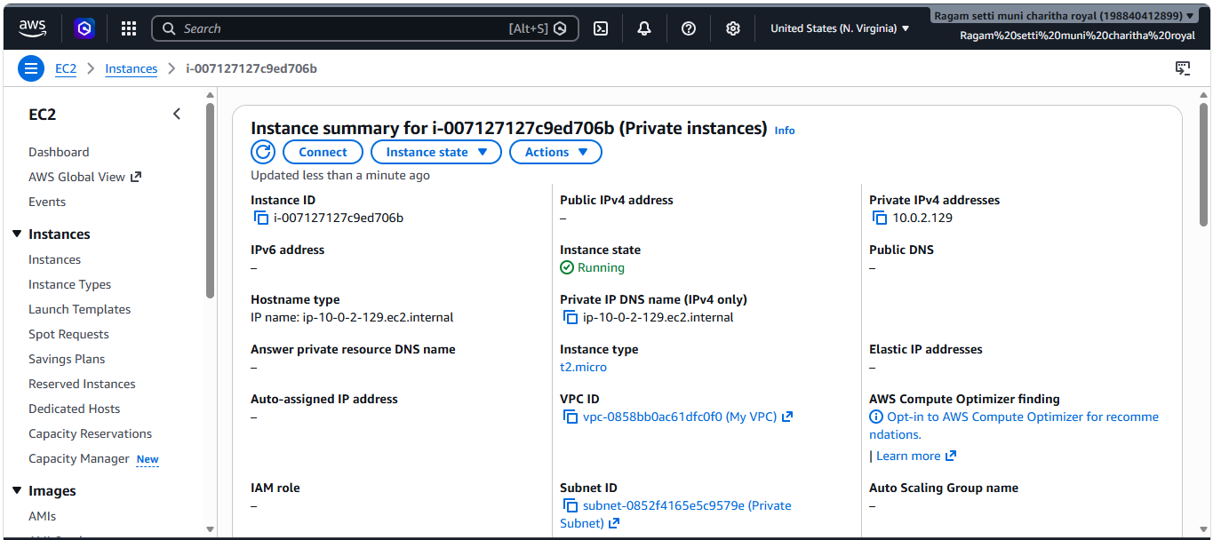
- Deploy Apache server on both EC2 instances with a sample index.html file.
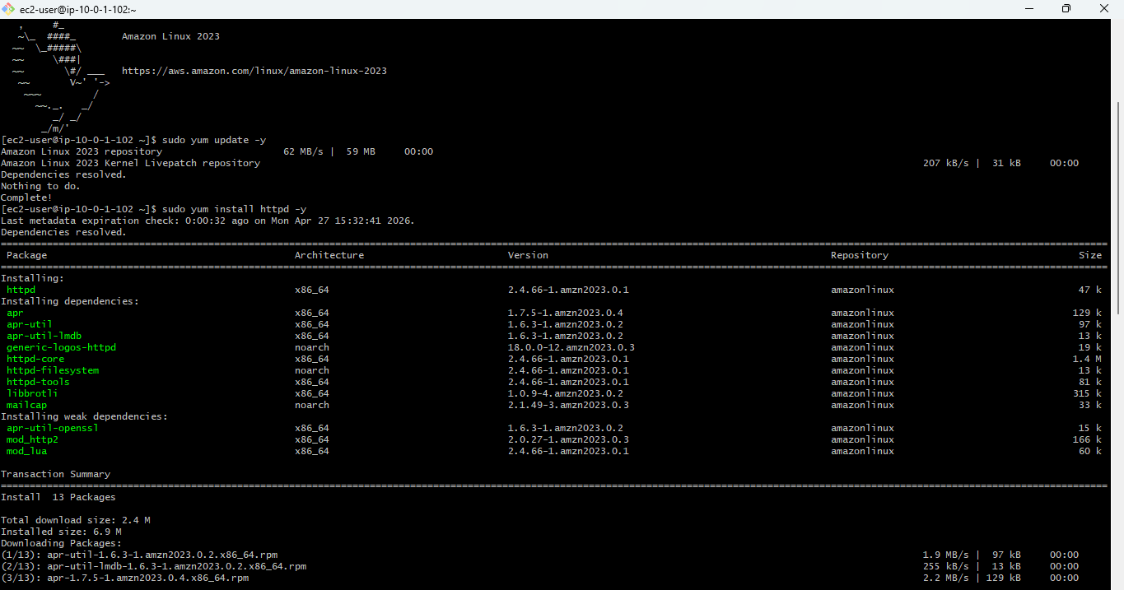
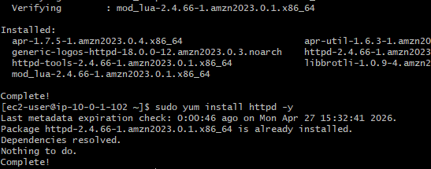
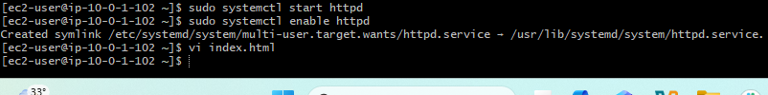
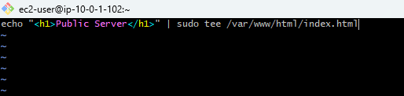
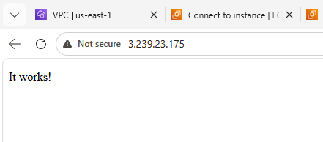
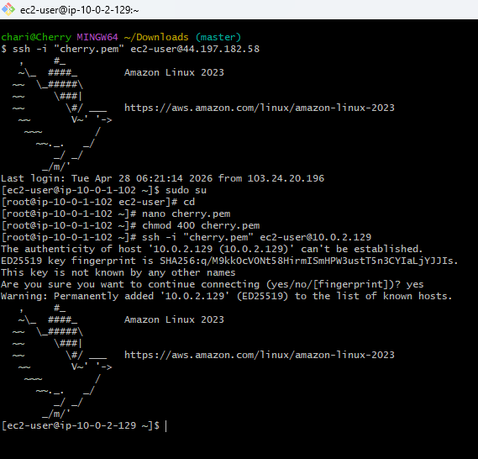
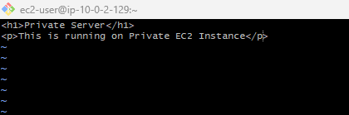
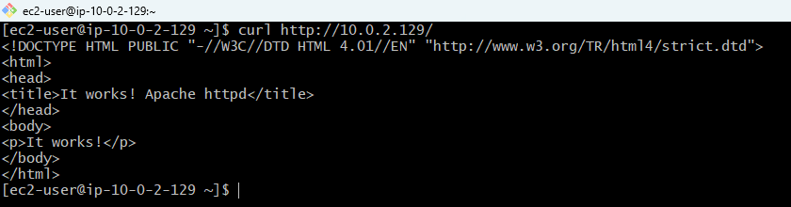
- Create one application load balancer and attach it to both EC2 instances.
- Opened the EC2 Load Balancers section in Amazon Web Services Console and created an Application Load Balancer.
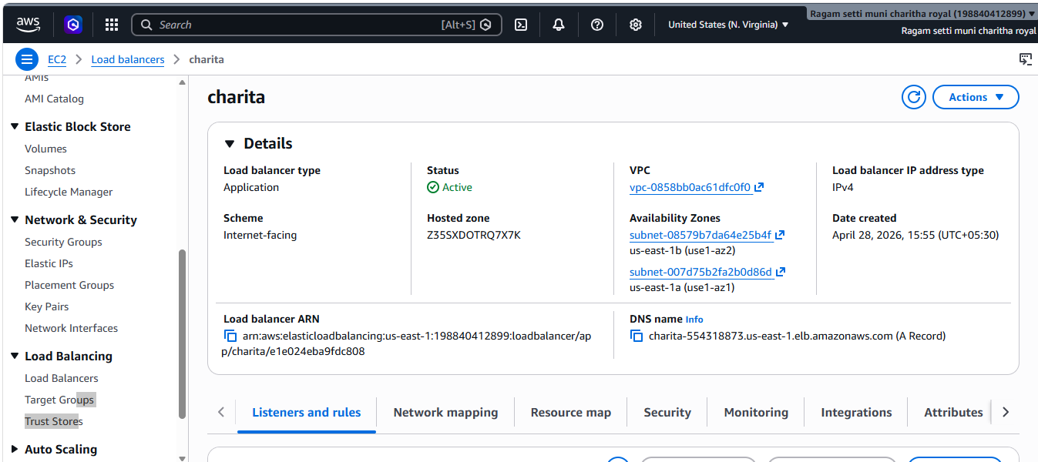
- Attached both EC2 instances to the target group and configured the load balancer successfully.
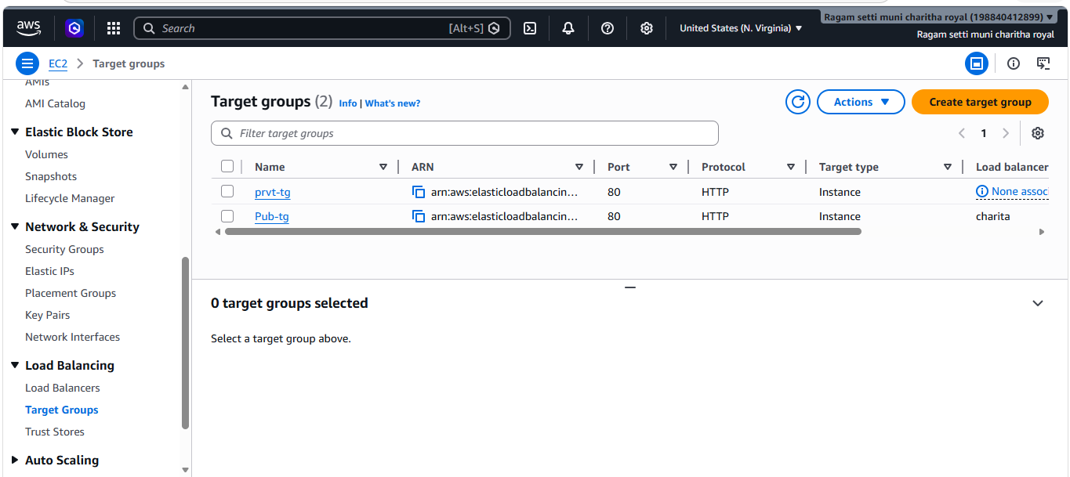
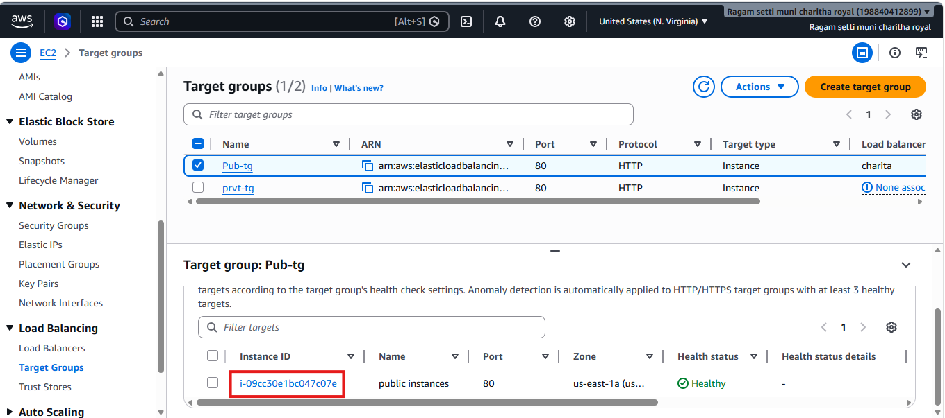
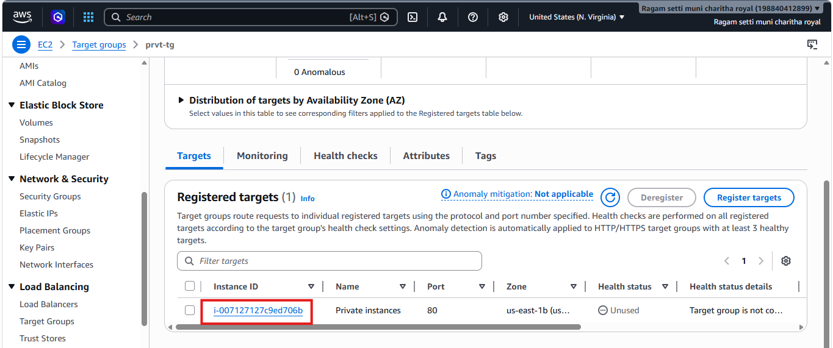
- Store application load balancer logs in S3.
- Opened the Application Load Balancer settings in Amazon Web Services Console and enabled Access Logs and selected s3 bucket.
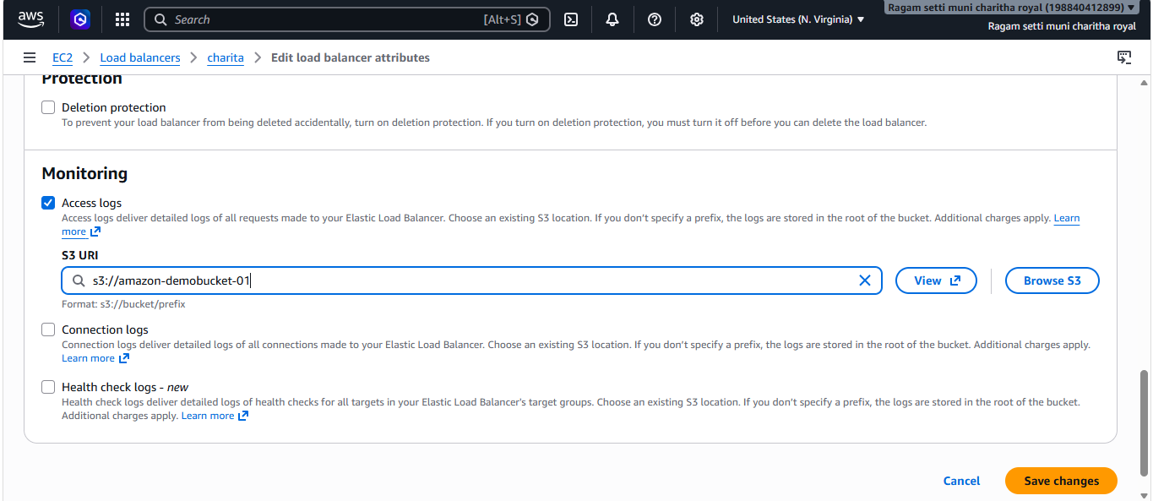
- Opened the Load Balancer Attributes section and enabled Access Logs.
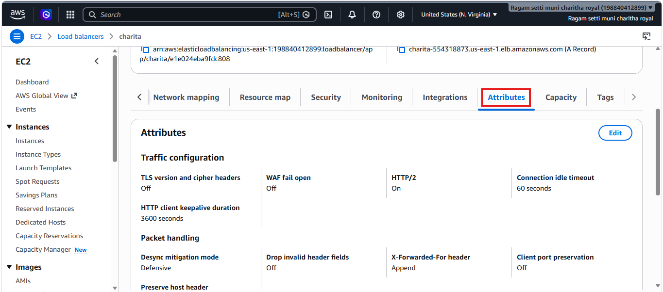
- Configured the S3 bucket to store Application Load Balancer logs successfully.
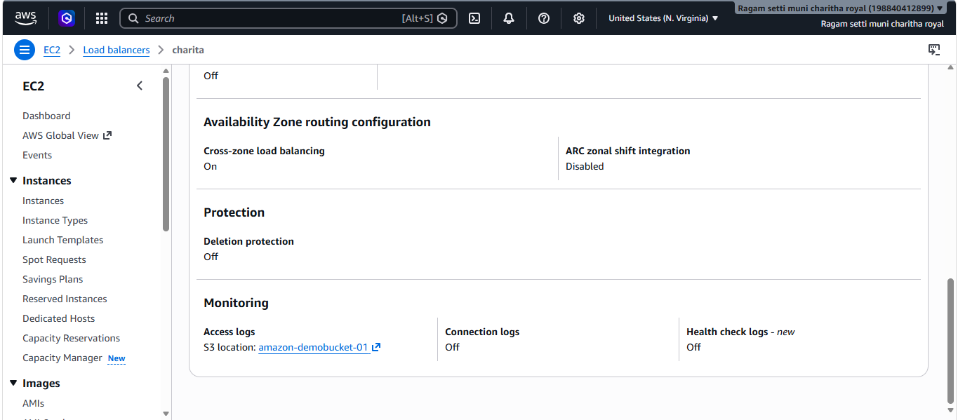
10.Store the VPC flow logs in a CloudWatch log group.
- Opened Amazon Web Services Console → Search VPC → Go to Your VPCs or Flow Logs.
- Selected the required VPC → Click Created flow log.
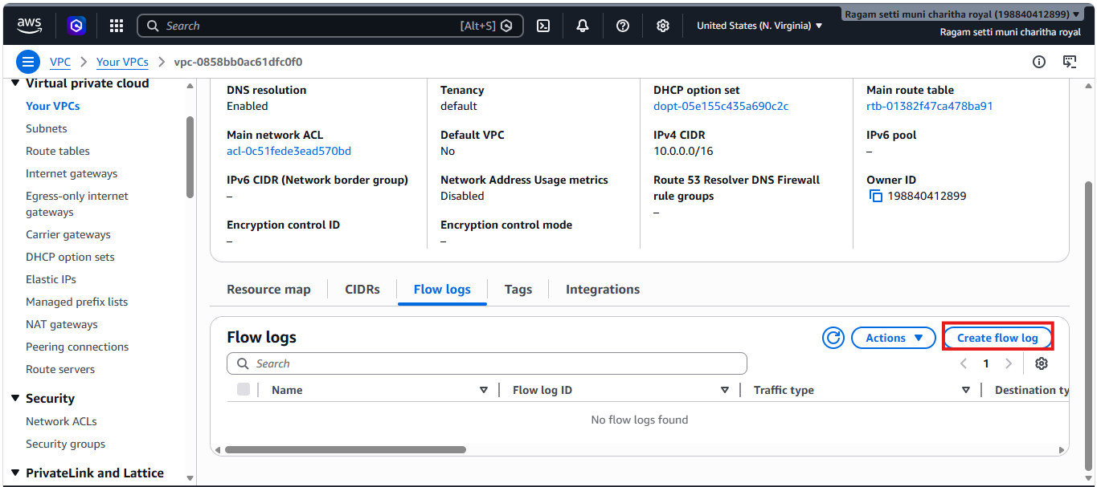
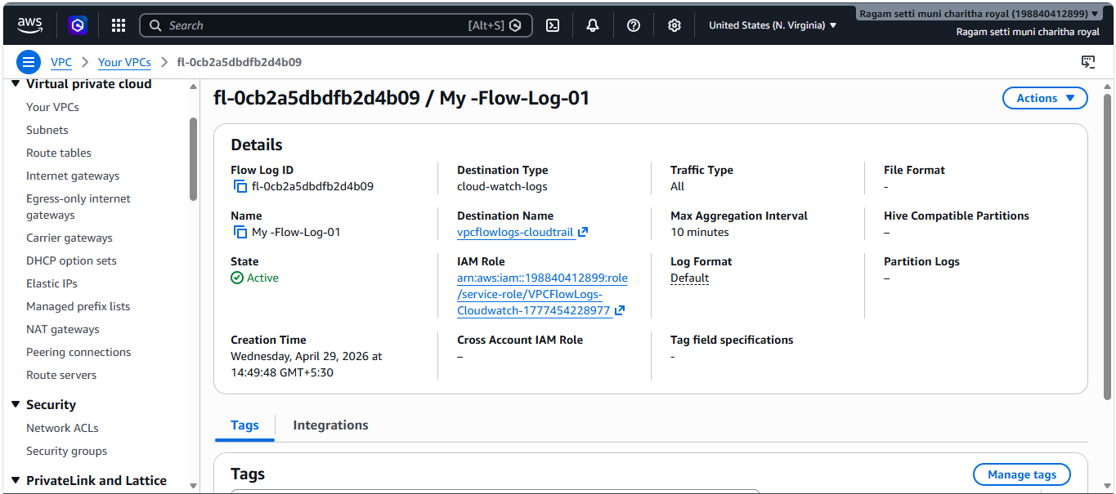
- Created a CloudWatch Log Group named vpcflowlogs-cloudtrail and configured VPC Flow Logs to publish network traffic logs into it successfully.
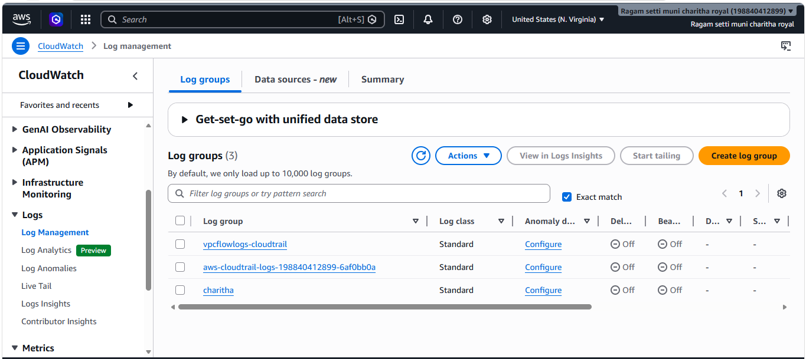
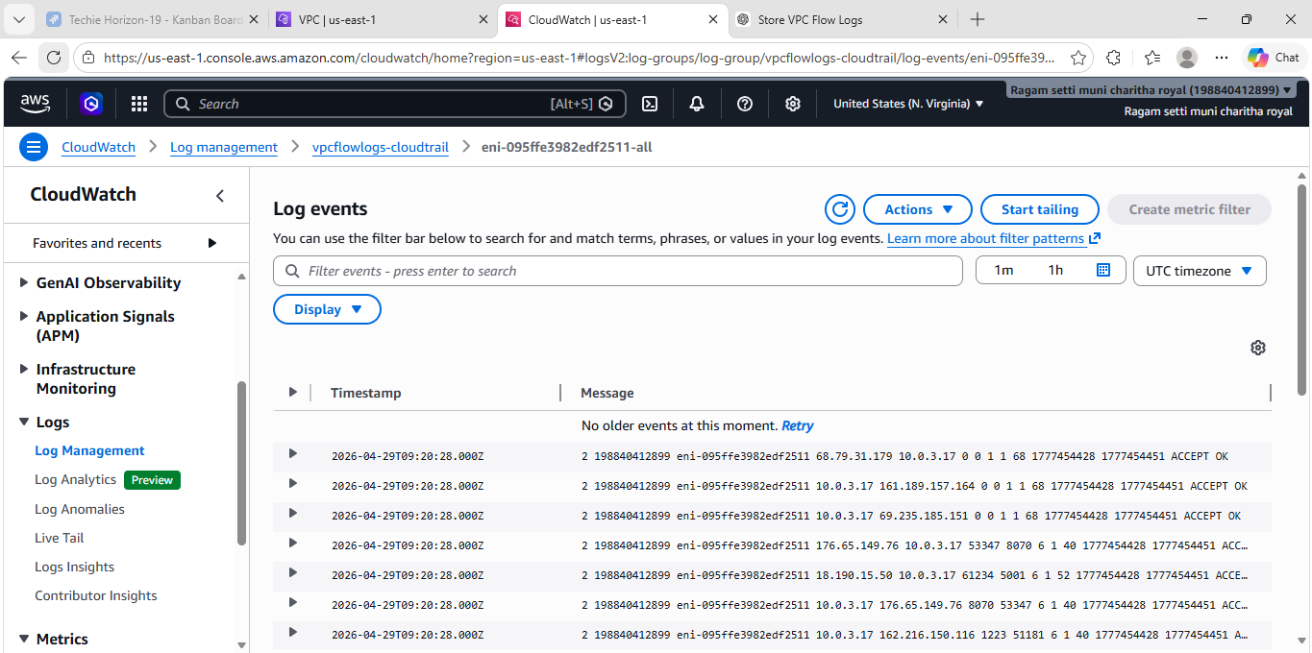
11.Create monitoring dashboards to monitor CPU utilization and to monitor the Apache service.
- CloudWatch Agent is active (running)
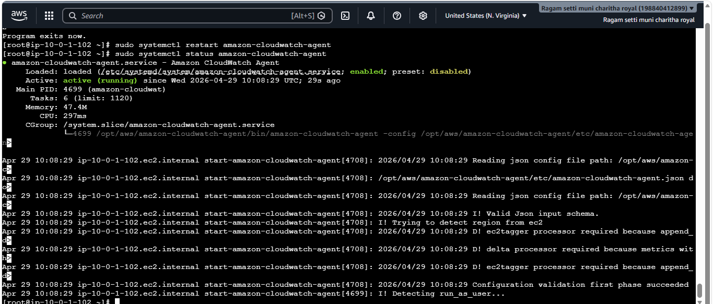
- Apache httpd is active (running)

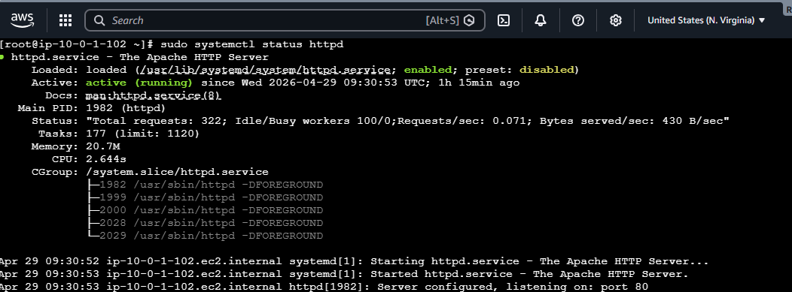
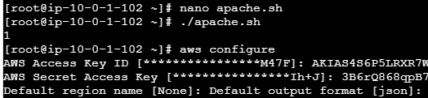
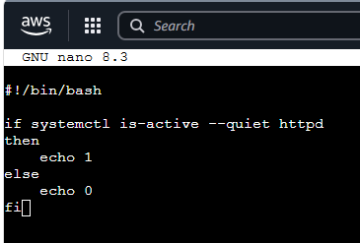
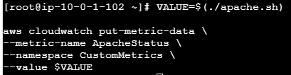
- Successfully verified the CloudWatch Dashboard by displaying the custom metric Apache Status.
- The dashboard shows a value of 1, confirming that the Apache (httpd) service is running properly and metric data is being published successfully.
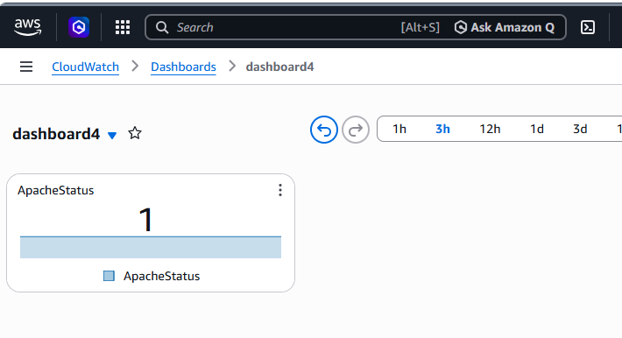
12.If CPU utilization is more than 70%, then it should trigger auto scaling and launch new instance.
- created an EC2 Launch Template named Mytemplate with required instance configuration to use in Auto Scaling Group for automatic instance launches.
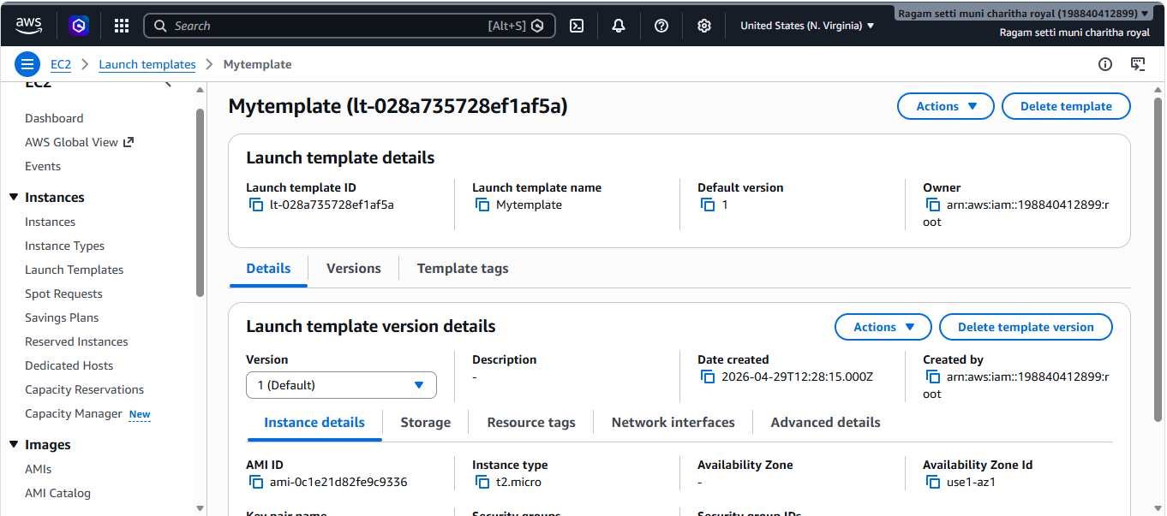
- Created Auto Scaling group-01 using the launch template and configured scaling policy for automatic instance management based on CPU utilization.

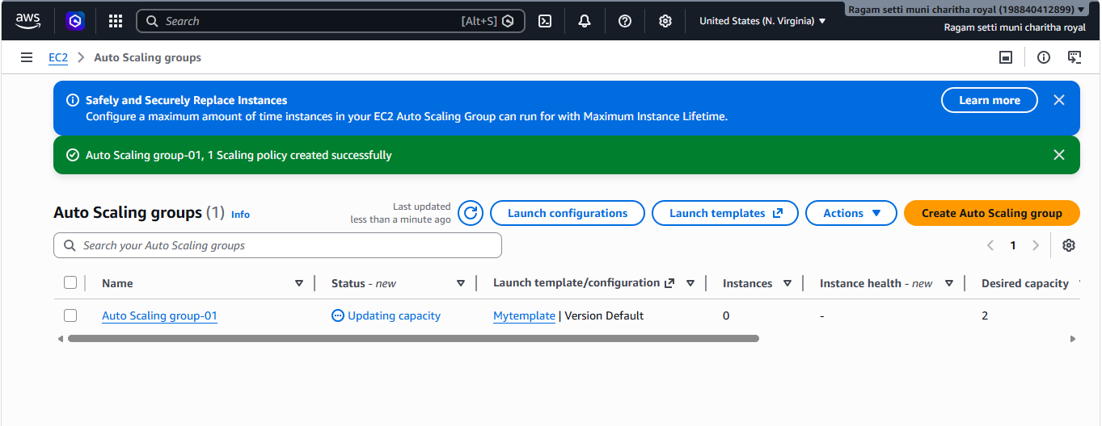
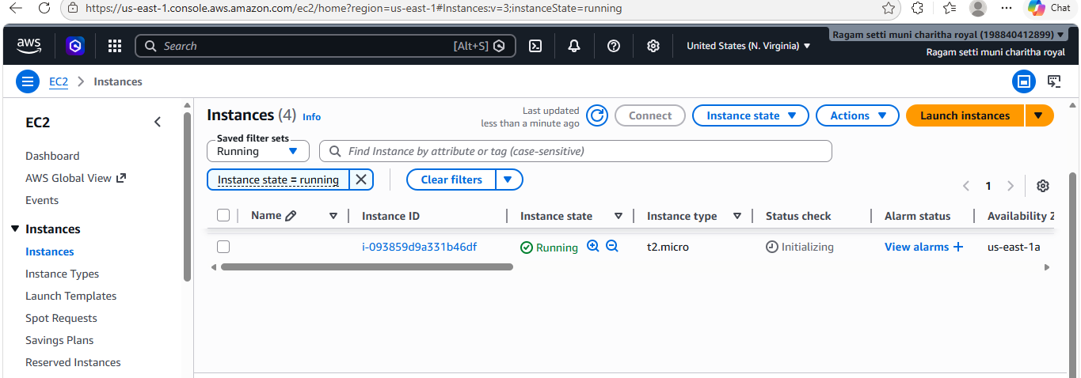
- Auto Scaling activity history confirms successful launch and replacement of EC2 instances based on health checks and scaling events.

